**FAITH JUNIOR SCHOOL-KASENGE**

**PRIMARY FOUR EXAMS**

**ENGLISH MID TERM THREE 2023-SET 2**

***Time Allowed: 2 Hours 15 Minutes***

**Name:_____________________________________________**

**SECTION ‘A’ (50 Marks)**

***In each of the questions, 1 – 5, fill in the blank space with a suitable word***

1. There wasn’t ________________ sugar left in the bowl.
2. Go to the ___________________ and borrow a book.
3. __________ Peter or Paul attended the debate yesterday.
4. I cannot go to school _______________________I paid the money
5. There goes the woman _______________ husband was arrested.

***In each of the questions 6 to 15, use the correct form of the given word in brackets to complete the sentence.***

1. Acen was the _____________________ in the race. (**five**)
2. Who is the _____________________ girl of the two? (**tall**)
3. They _____________________ a test last week. (**do**)
4. Mary _____________________ food last night. (**cook**)
5. A chameleon walks ___________________________ (**slow**)
6. They _____________________ writing an examination now. (**to be )**
7. All the ________________ drowned in the lake. (**ox**)
8. The children are ______________________ in the field. (**run**)
9. James wrote an interesting _______________________ about their trip to Entebbe. (**compose**)
10. A _________________ driver knocked down a school boy. (**care**)

***In questions 16 and 17, write the abbreviations in full***

1. Feb. : ___________________________________________________
2. won’t : ___________________________________________________

***In questions 18 and 19, arrange the given words in alphabetical order***

1. June, March, May, April

_____________________________________________________________________

1. blunt, black, blank, bleed

_____________________________________________________________________

***In questions 20 – 23, rewrite the sentences giving the opposite of the underlined words***

1. She always reaches school **late**.

____________________________________________________________________

1. A pencil is **more expensive** than a fountain pen.

_____________________________________________________________________

1. I always visit my **friends** in the holidays.

______________________________________________________________________

1. The price of fuel is **low** in our district.

______________________________________________________________________

***In questions 25 and 25, use the words below in sentences to show that you understand their meanings***

1. hear;

___________________________________________________________________

1. here;

___________________________________________________________________

***For questions 26 – 27, rewrite the sentences giving one word for the underlined group of words***

1. Kato is **a man who makes** **furniture**.

____________________________________________________________________

1. We went to the **place where food is cooked.**

___________________________________________________________________

***For questions 28 – 30, re-arrange these words to form correct sentences***

1. knocked was Musoke down.

______________________________________________________________________

1. your Where father is?

______________________________________________________________________

1. turn good another One deserves.

___________________________________________________________________

***Sub – Section II***

***In each of the questions 41 – 50, rewrite the sentences as instructed in the brackets***

1. That is the dog. It stole our meat. ***(Use……………which…………………)***

___________________________________________________________________________

1. I like fish more than meat. ***(Use:…………prefer…………..)***

___________________________________________________________________________

1. Martina is a beautiful girl. Noella is a beautiful girl. ***(Join beginning: Both……..)***

___________________________________________________________________________

1. Sebastian is very fast. He can win the race. ***(Use:……..so……that…….)***

___________________________________________________________________________

1. Judith came early. She did not complete her work. ***(Begin: Although……..)***

___________________________________________________________________________

1. There is some porridge in the flask. ***(Use:…….any…….……)***

___________________________________________________________________________

1. I am ten years old. ***(Write a suitable question for the above response…….…..)***

___________________________________________________________________________

1. I am very tired. I cannot run any more. ***(Use:……….too……..…to…….…..)***

___________________________________________________________________________

1. edward and keren are going to tanzania. ***(Punctuate correctly )***

___________________________________________________________________________

1. He lost direction to my home. He did not ask. ***(Join as one sentence using:….. because.….…..)***

___________________________________________________________________________

1. She wanted to complete her homework. She came very early. ***(Use:……… in order to ……….)***

___________________________________________________________________________

1. My father is a very tall man. ***(Begin: What ……………….! )***

___________________________________________________________________________

1. We swept the classroom yesterday. ***(Rewrite ending:……….now. )***

___________________________________________________________________________

1. That tomato is fresh. ***(Rewriting beginning: Those…..)***

___________________________________________________________________________

1. That is the lady. Her bag was stolen. ***(Use:………….whose………….)***

___________________________________________________________________________

1. Bob went to town. Angella went to town. ***(Join using:………..and…………)***

___________________________________________________________________________

1. Martha is playful. She is like a kitten. ***(Join using:………as………..as……….)***

___________________________________________________________________________

1. This is the place. The children go to relax. ***(Join using:…………where………)***

___________________________________________________________________________

1. Stella broke the glass. ***(Begin: The glass……………)***

___________________________________________________________________________

1. Birds of the same feathers ___________________________________ ***(Complete sensibly)***

**SECTION ‘B’ (50 Marks)**

1. ***Read the passage below and in full sentences answer the questions that follow***

Last week, Mr. and Mrs. Baguma decided to hold a birthday party for their daughter Martha. Martha had turned six years. Mrs. Baguma bought a new dress and shoes for Martha. Then the father decided to buy a cake, soda and other food stuffs.

They decided to invite forty guest to attend the birthday party. The party took place at Lagrants Hotel. At the hotel, all the invited guests were very happy and bought gifts for Martha. After cutting the cake, the visitors gave Martha many gifts like dolls, balls, video games and skipping ropes. When the visitors left, Mr. Baguma took his family back home.

What a happy day it was!

***Questions***:

1. When was the birthday party held?

_______________________________________________________________________

1. Whose birthday party was it?

_______________________________________________________________________

1. How many years did Martha turn?

_______________________________________________________________________

1. What did Mrs. Baguma buy for Martha?

_______________________________________________________________________

1. How many guests were invited to the party?

_______________________________________________________________________

1. Where was the birthday party held?

_______________________________________________________________________

1. When did the visitors give Martha the gifts?

_______________________________________________________________________

1. Write **two** gifts that were given to Martha.
2. _________________________________________________________________
3. _________________________________________________________________
4. Write a suitable title of the passage.

______________________________________________________________________________________________________________________________________________

1. ***Read the poem and answer the questions that follow in full sentences***

**GOD’S CREATION**

God created many interesting things,

living and non-living things.

Above all, He created man.

Blessed with intelligence and wisdom.

man used God’s creation,

To design different shapes.

Triangle with three sides,

square with four sides,

rectangle with two opposite equal sides,

and circle with a round shape.

***Tianah***

**Questions:**

1. What is the poem about?

_____________________________________________________________________

1. How many stanzas are in the poem?

_____________________________________________________________________

1. What is man blessed with?

_____________________________________________________________________

1. How many shapes are mentioned in the poem?

_____________________________________________________________________

1. What name is given to a shape with three sides?

_____________________________________________________________________

1. Write down any one shape that is not mentioned in the poem.

_____________________________________________________________________

1. Who wrote the poem?

_____________________________________________________________________

1. Write down the title of the poem.

_____________________________________________________________________

1. Write the opposite of **‘poet’**

_____________________________________________________________________

1. **(A) *Re-arrange the following sentences to form a good story***
2. Relatives and friends attended.
3. My sister wedded.
4. They ate and everybody was happy.
5. Last Saturday,
6. The wedding was at St. John’s church.

***Good story***

1. ______________________________________________________________________
2. ______________________________________________________________________
3. ______________________________________________________________________
4. ______________________________________________________________________
5. ______________________________________________________________________
6. Because he pays school fees for them.
7. In Jambo Primary School.
8. They like their father very much.
9. Tome and Joel are brothers.
10. They are both in Primary four.

***Good Story***

1. ______________________________________________________________________
2. ______________________________________________________________________
3. ______________________________________________________________________
4. ______________________________________________________________________
5. ______________________________________________________________________
6. ***The calendar below is for the month of April 2021. Study it and answer the questions that follow***

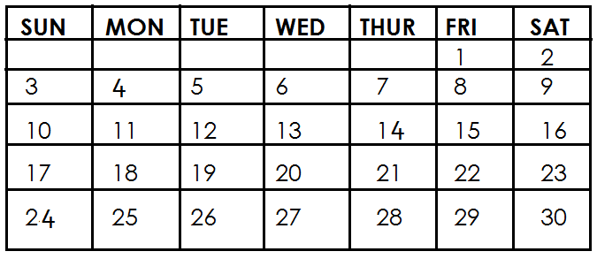

**Questions**:

1. Which month is shown above?

______________________________________________________________________

1. On which day did the month begin?

______________________________________________________________________

1. How many days are in this month?

______________________________________________________________________

1. How many Saturdays are shown on the calendar?

______________________________________________________________________

1. On which day will the month end?

______________________________________________________________________

1. For which year is the above calendar?

______________________________________________________________________

1. On which day was 20th April?

______________________________________________________________________

1. How many days make a week?

______________________________________________________________________

1. Which month is followed by the above month?

______________________________________________________________________

1. Write **‘Fri’** in full.

______________________________________________________________________

1. ***Choose the correct word from the box below to complete the story correctly.***

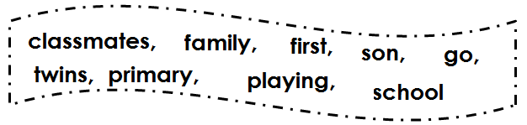

Mr. Sengoro and his wife have a small ____________________. They have only ___________________children. They are Winnie, Willy and Wendy. Winnie is the __________________ born. Willy and Wendy come after Winnie. They are ______________________. Willy is the only ______________________. All the children _______________ from the same school. Willy and Wendy are in primary four.

Winnie is in ___________________ Five. All of them enjoy __________________ with their _________________ at ______________________

***E N D***